Pwd : present working directory
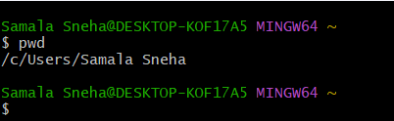
Ls : list of files
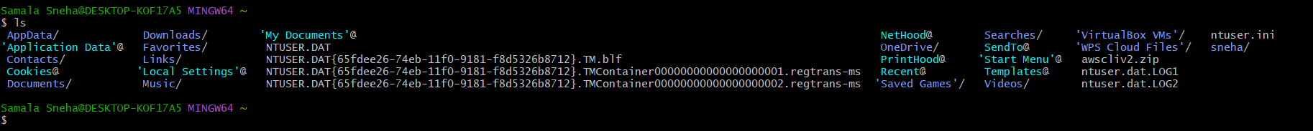
LL : list of files
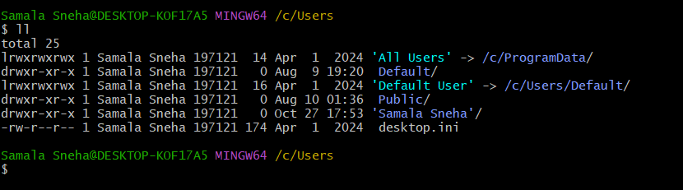
Cd : chage directory
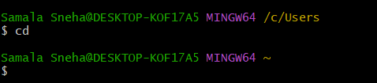
Ls -a : list of hiden files
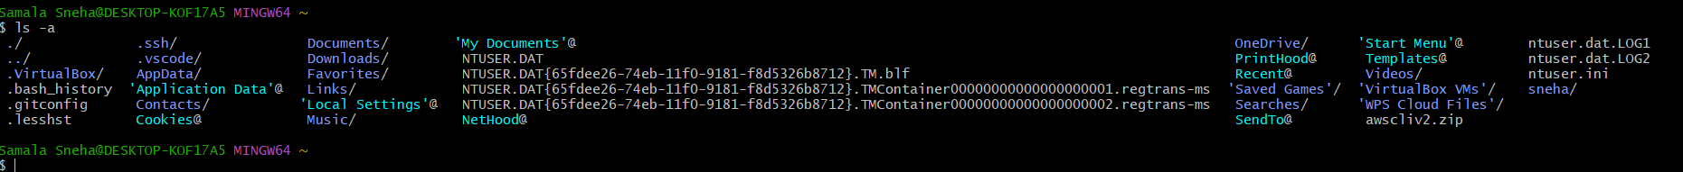
Clear : clear the screen
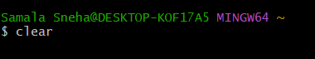
History : show the history of commends
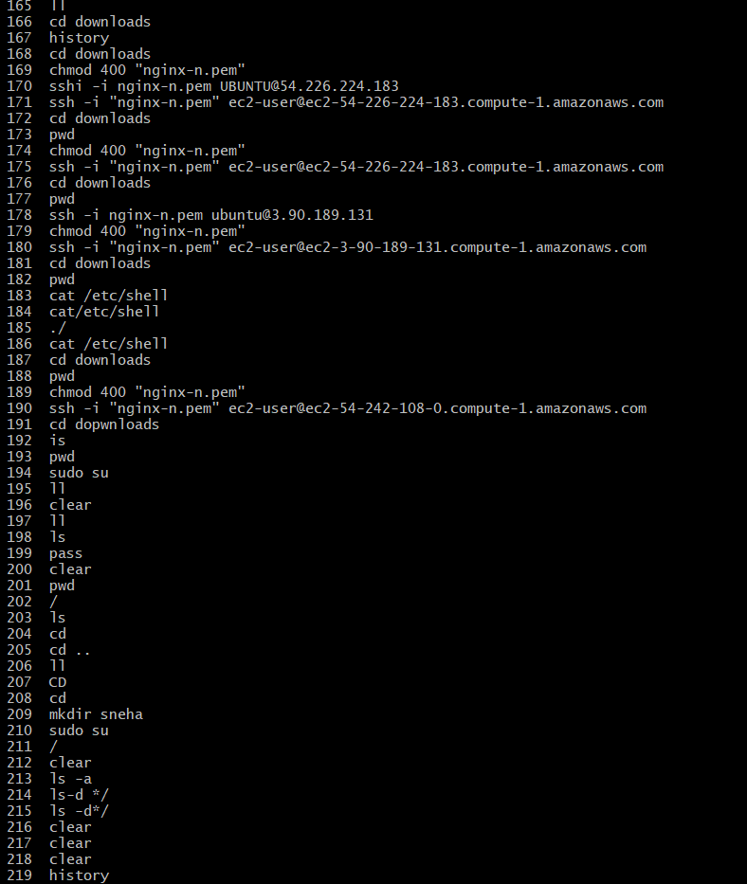
Touch : create the file
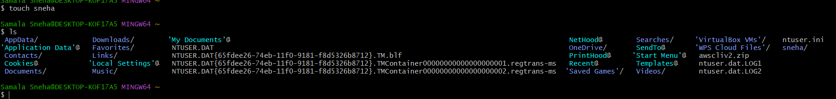
Date
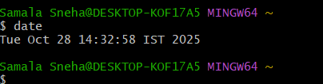
Vi : edit the file
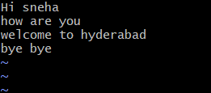
Cat : read the content
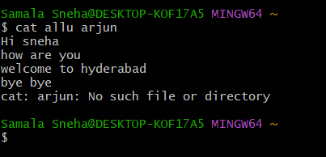
Nano :is also for edit
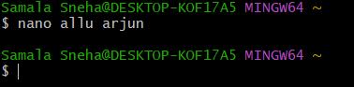
Whoami : shows current login user
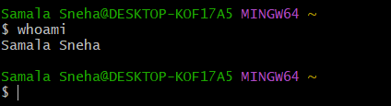
Mkdir : created the directory
Rm -rf : remove the directory
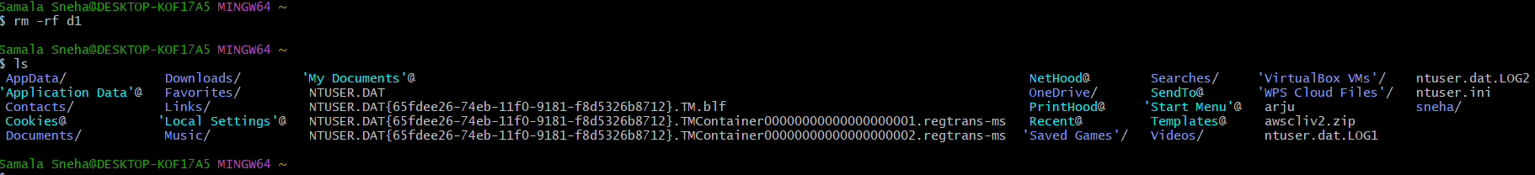
Cd ~ : go to home directory
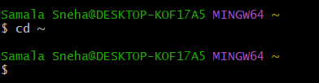
Cd.. : one step back
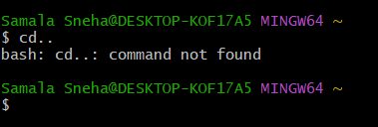
cd../.. : two steps back
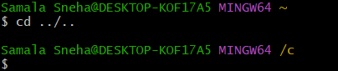
Ls -ltr

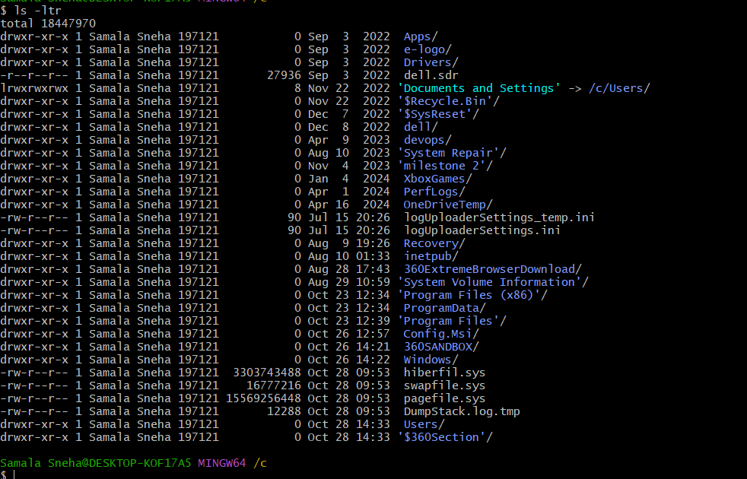
Ls -d */: list all the directories
Ls -ll : hidden files and list pf all files
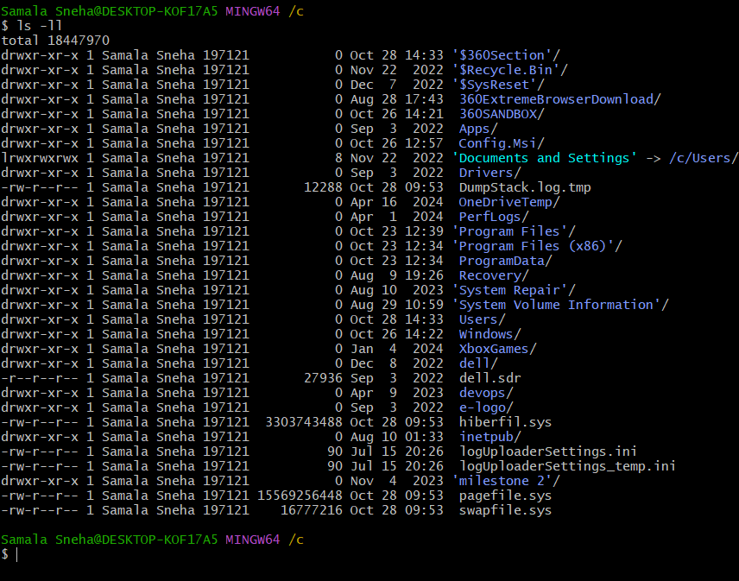
ls -ls : list of files in sorting format

